BLOCKCHAIN ASSIGNMENT:VOTING(ballot.sol)

-Karthik SR(AMSCU3CD20031)

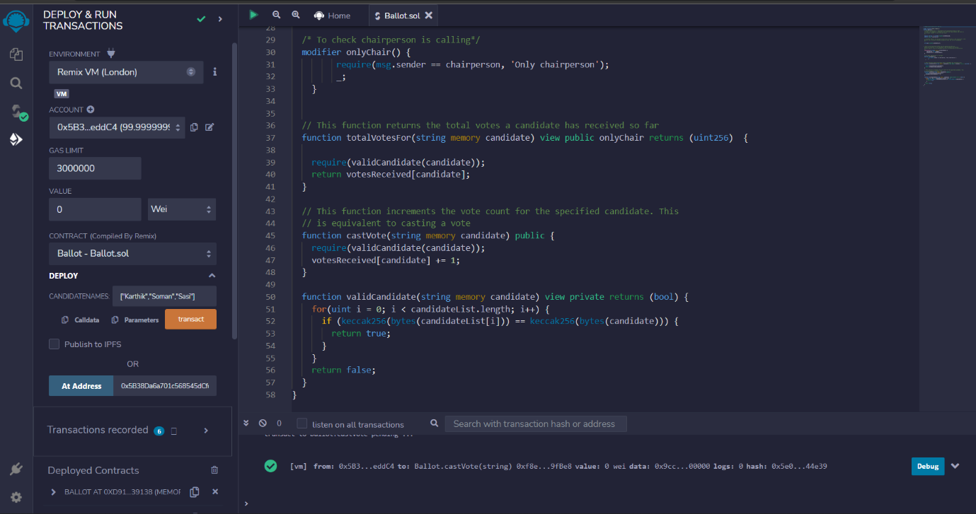

Opened Ballot.sol

Deployed the solidity code file and entered candidate names as 🡪 ‘Karthik’,’Soman’,’Sasi’

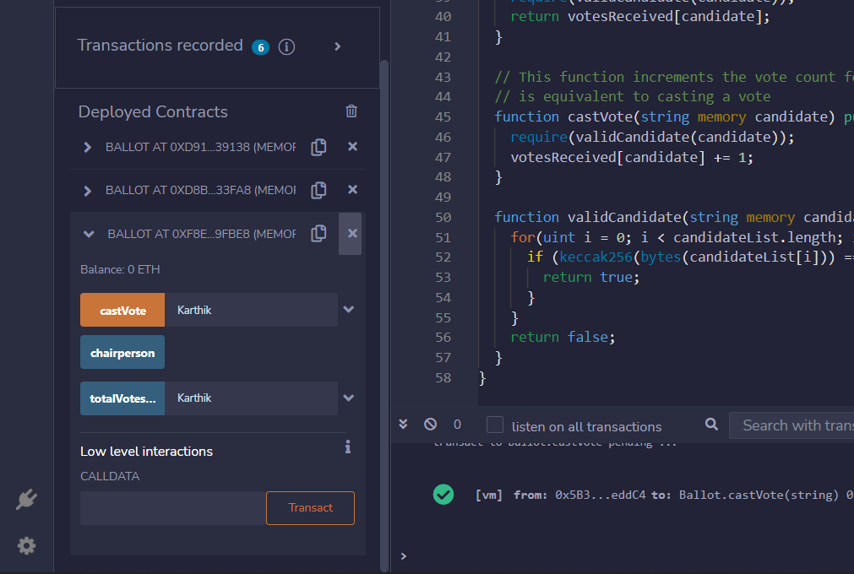

Casted a vote for the candidate ‘Karthik’

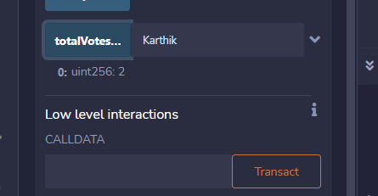

Entered a valid candidate name into ‘totalVotesFor’ function to see the vote count

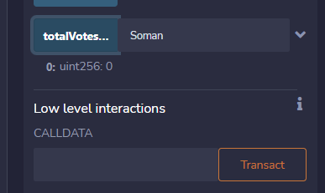

The other candidates have zero votes

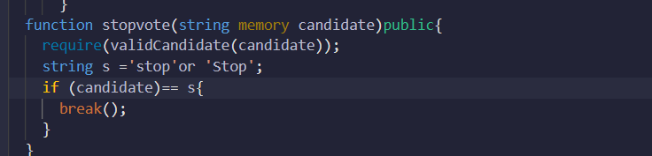

The chairperson can stop the vote by entering ‘Stop’ into the stopvote Function.

------------------------------------------------------------------------------------------------------------------------------------